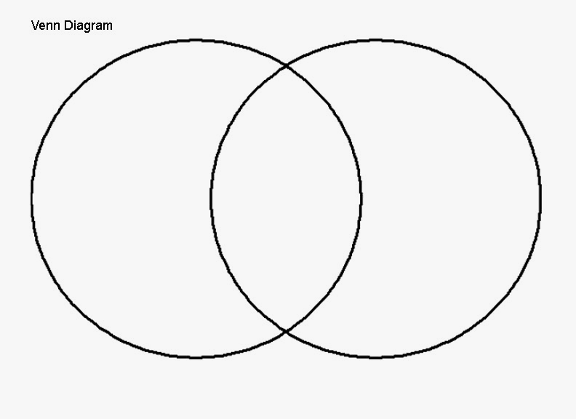

Name___________________________________________________Date_________________________

Inventor_________________________________Comparing_______________________________________________________________